**Make-up assignment:**

2.The user can select from a number of options when the application is opened. Making sure that the layout is always visible to users is essential for every programme. We should work quickly to complete the particular tasks in order to keep it interesting, such as

1. by using only a few colors in your designs,
2. One of the tools for designing a beautiful interface into any layout is color.
3. We shouldn't employ too many components.
4. We should Replace all of the text with pictures.
5. We can pick fewer fonts overall.
6. The final but not least step is to provide contrast to both the text and the image.

**3.** The features that I'll employ in the next chapters in addition to the standard queries like SELECT, DROP, INSERT, and UPDATE are those that process huge data and address regulated inquiries pertaining to the entity relationship model. Big data databases can contain petabytes of structured, semi-structured, and unstructured data without the need for tight schemas. The majority of large data databases are NoSQL or non-relational databases, which may be constructed using a parallel design. It might make it possible to process enormous amounts of big data quickly and affordably while also handling several concurrent queries. A high-level data model called an entity relationship model is used to specify the data items and relationships for a specific system. It can create a database's conceptual design.

5**.** As a user, Alan can modify any record in the table by the UPDATE statement. It can make the updation process of the table much easier. Now, if we describe the user story then Alan, who is a user, can modify the information of the table by using the UPDATE query in the python script very easily.

***Post your code to github. Also, include a report containing the following***:

1**.** The user interface that I have used here is Graphical user interface. In the Graphical user interface, the interface that I have used here is Tkinter. It is used in GUI very commonly. The easiest way to build a GUI application is by using python with tkinter. It can provide a very powerful interface which is object-oriented to the Tk GUI toolkit.

3. The queries which I will use here are SELECT, INSERT, UPDATE and DELETE.

The SELECT query is used for determining which data columns to display in the results of a query. You can use other choices to display data that is not contained in a table column. The INSERT query is used for inserting data on the table. For deleting any record from the table the DELETE query is used. And for modifying any record from the table the query UPDATE is used.

**4.**

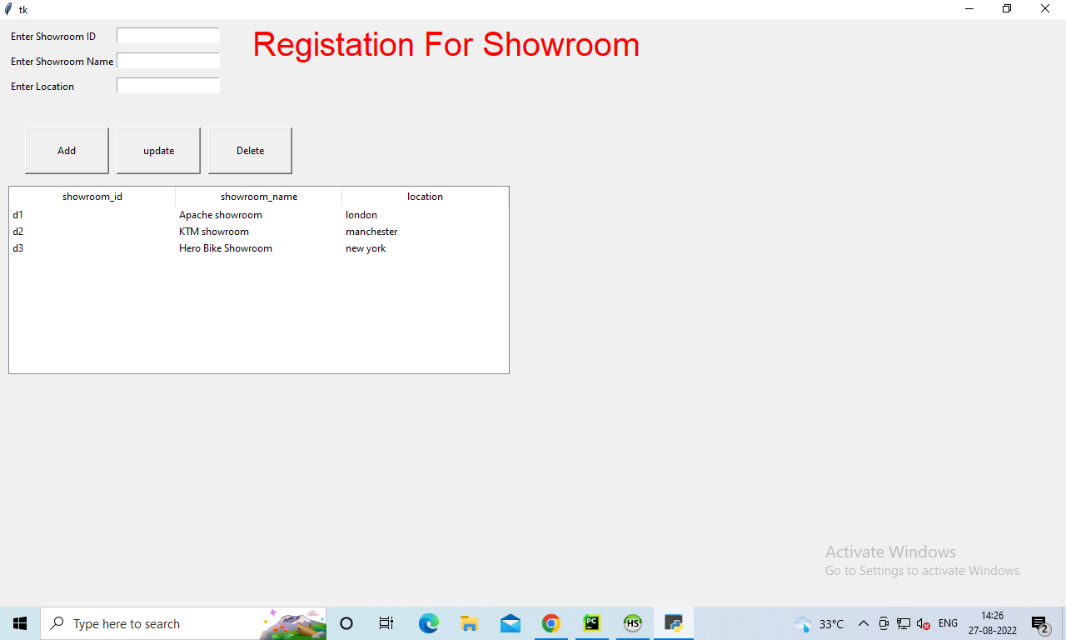

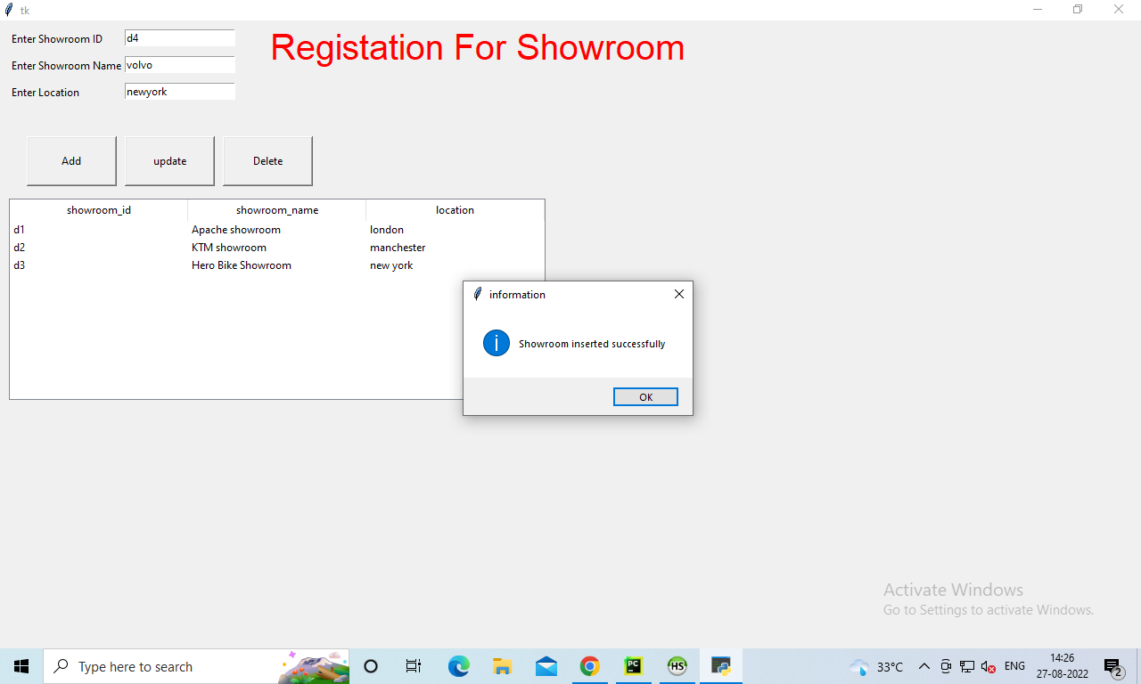

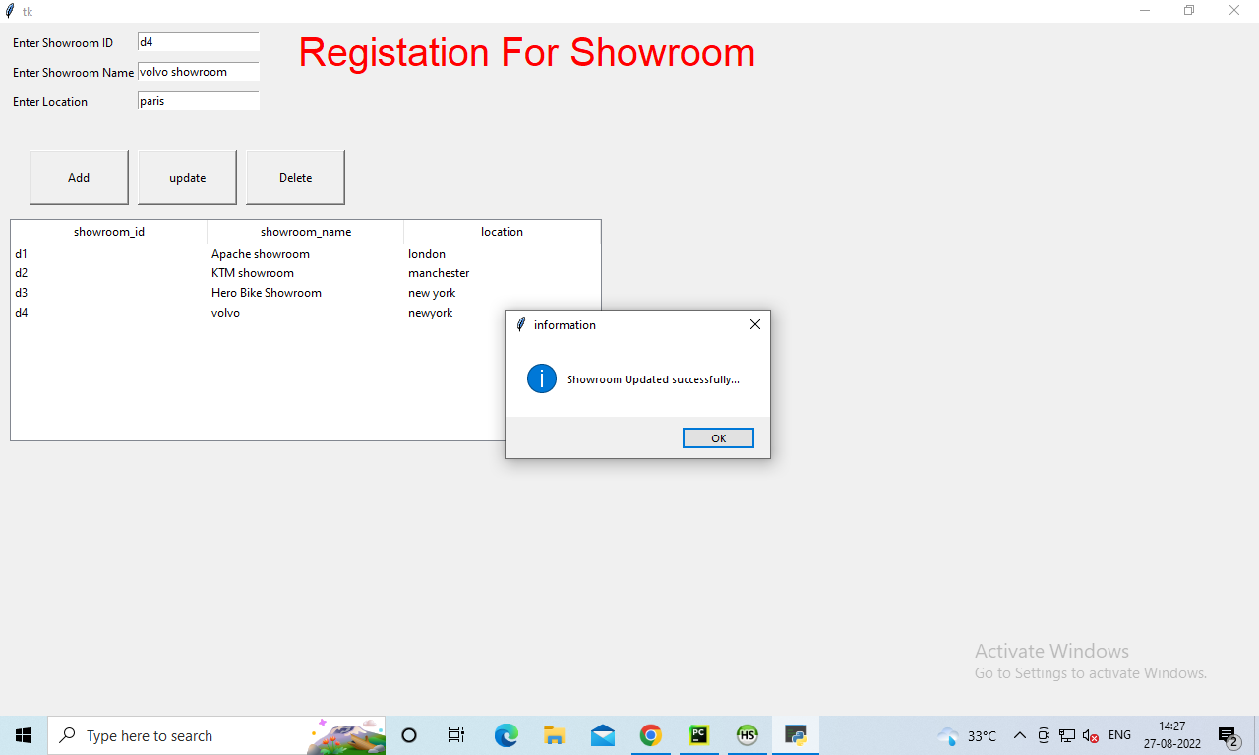

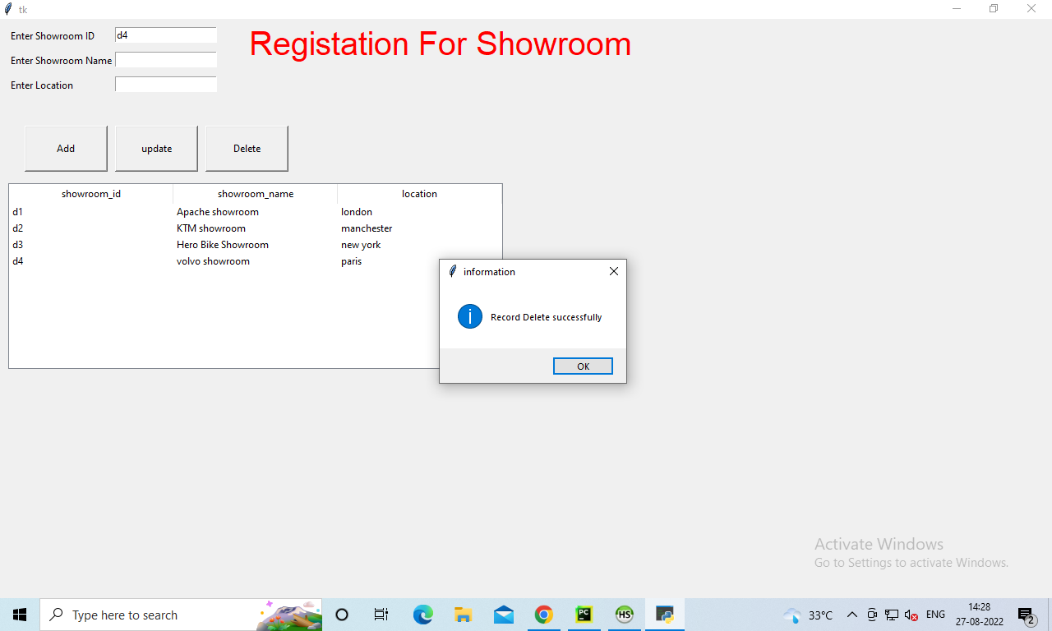

5.  
  
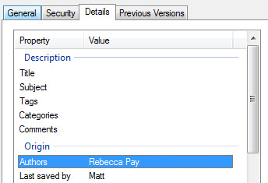

I had a professional design a template for me, and then I updated it afterwards. Your documents should only have your own name in these fields. They should NOT be blank.

This seems more complicated, but I need you to develop your own designs so that repeats/copies are highly unlikely. A successful project will remove suspicion and be worth 20 points.